C.V
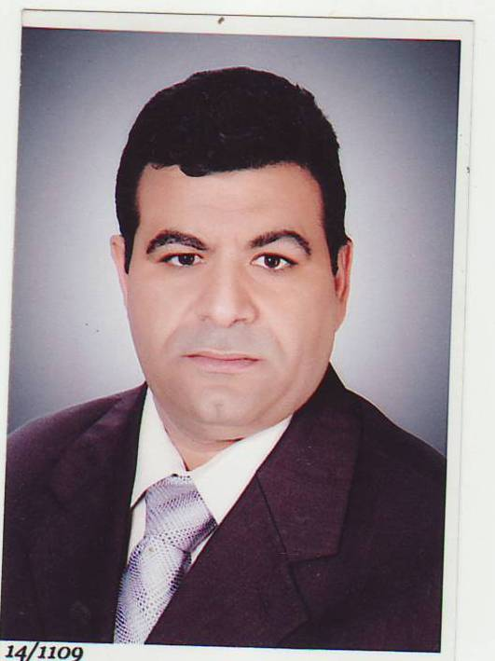

Name : Mohamed Mahmoud Ahmed Shahata
Date of Birth : 6 / 7 / 1971.
Qualification : B.Sc, M.Sc and phD – Chemistry Department.
Faculty of science – Assiut university
Meratily : Married .
Occupation :- University staff member –
- The Director General of the Environment Affairs Assiut branch
of the Ministry of the Environment.
- General Supervisor of Environmental, Safety and Occupational Health, Assiut University Hospitals, Assiut University .
- Member of Infection Control Unit in Assiut University Hospitals .
- Member of Environmental Affairs, Faculty of Medicine Assiut University .
- Member of Safety and Occupational Health, Faculty of Medicine Assiut University .
- Secretary – General for United of Youth , Assiut Governorate .
Business Address : Egypt – Assiut University Hospitals.
Home Address : Elwan – east side P.O. Box : 71763
City : Assiut Country : A.R. Egypt .
Phone : +2088 2271429 - Mobile : +201007361355
E. mail : E. mail: mohamedshahata67@hotmail.com,

mohamedshahata@med.au.edu.eg

Graduated Studies : phD. degree –Inorganic and analytical Chemistry.

Published Paper :
- Differential Pulse Polarographic (DPP) of Poly (8–Hydroxyquinoline) Matrix, Mostafa M. Kamal, Seddique M. Ahmed, Mohamed M. Shahata and Yassien M. Temerk, Anal. and Bioanal. Chem., 372, 843 – 848, (2002).
- Spectrophotometric Studies of the Coordination Polymer Based on Poly (8–Hydroxyquinoline) Matrix, Seddique M. Ahmed, Mohamed M. Shahata and Mostafa M. Kamal , Journal of Inorganic and Organometalic Polymer , Vol. 13, No. 3, ( 2003 ).
- Cationic Mobility on Poly (8-Hydroxyquinoline) Matrix. Mohamed M. Shahata, " The Second Conference for Youth Scientists, Basic science & Technology " Assiut university – Oct. 2008
- Cation exchange mobility on Poly(8-hydroxyquinoline) matrix, Mostafa M. Kamal, Abd El-Aziz Y. Al-Syed, Seddique M. Ahmed and Mohamed M. Shahata, International Journal of Inorganic and Organometalic Polymer and material, Vol. 19, No 4 , 501-506 (2009) .
- Pre-concentration of Some Heavy Metal Ions with AlO-HQ and AlO-PHQ and their studies by FTIR and Spectroscopy. Mostafa M. Kamal, Abd El- Aziz Y. El- Sayed, Seddique M. Ahmed, Ahmed A. Omran, and Mohamed M. Shahata , Arabian Journal of Chemistry, in press (2011).
- Adsorption of Some Heavy Metal Ions by Used Different Immobilized Substances on Silica Gel. Mohamed M. Shahata , Arabian Journal of Chemistry, Vol.9, Issue 6, 755 – 763, (2016).
- Cathodic Stripping Differential Pulse Voltammetric Determination of Poly(8–Hydroxyquinoline) Matrix. Mohammed. M. Shahata, Seddique. M. Ahmed and Mostafa M. Kamal, IJPAC-International Journal of Pure and Applied Chemistry, Vol. 8• No. 3 • 209-216(2013).
- Determination of the Formation Constants of Some Metal Ions Coordinated with poly (8–Hydroxyquinoline). Mohamed M. Shahata, International Journal of Advanced Research (2014), Volume 2, Issue 6, 96-109.
- Formation Constants and Partial Formation Constants of Some Metal Ions Coordinated with 8–Hydroxyquinoline by Potentiometric Titration. Mohamed M. Shahata. American Journal of Chemistry and Application. Vol. 2, No. 3, 2015, pp. 37-46.
- Evaluation of The River Nile Water Quality Around The New Assiut Barrage and Its Hydropower Plant. Mohamed M. Shahata and Thabet A. Mohamed, International Journal of Advanced Research (2015), Volume 3, Issue 9, 184 – 193.
- Determination of Some Heavy Metal Ions and Water Quality In Ground Water of Many Wells In Assiut , Egypt. Mohamed M. Shahata and Saaid H. Abd- Elaal, International Journal of Advanced Research (2016), volume 4, Issue 10, 503 - 521.

Reviewer Paper :
I have been appointed as Reviewer of the journal (Premier Publishers);
- Journal of Environment and Waste Management
- International Research Journal of Chemistry.

Reviewer Paper :
1- Manuscript Number: ARABJC-D-11-00238
Extraction of some Strategic Elements from Thorium-Uranium Concentrate using Bioproducts of Aspergillus ficuum and Pseudomonas aeruginosa.

2- Manuscript Number: ARABJC-D-11-00646
Heavy metals and color retention by a synthesized inorganic membrane
A. Belouatek, A. Chougui, K. Zaiter
Laboratoire membrane, Centre universitaire de Relizane 48000 Algérie

3- Manuscript Number: ARABJC-D-12-00878
Effect of chromium speciation on its sorption mechanism onto grape stalks entrapped into alginate beads.
Carlos Escudero a, *, Núria Fiol a, Isabel Villaescusa a, Jean-Claude Bollinger
a Chemical Engineering Department, Universitat de Girona, Avda. Lluís Santaló, s/n, 17075 Girona (Spain)
b Université de Limoges, Groupement de Recherche Eau Sol Environnement (GRESE), Faculté
des Sciences, 123 avenue Albert Thomas, 87060 Limoges (France)

4- Manuscript Number ARABJC-D-13-00163
Investigation of electrochemical reduction of isatin-monohydrazone in protic mediaS. Çakıra,*, E. Biçerb, E. Yılmaz Arslana
a Department of Chemistry, Faculty of Science, Gazi University, 06500 Teknikokullar- Ankara, TURKEY
b Department of Chemistry, Faculty of Arts & Science, Ondokuz Mayıs University, 55139, Atakum-Samsun, TURKEY

5- Manuscript Number: ARABJC-D-13-01261
Solid Phase Extraction Liquid Chromatography Mass Spectrometry Method with Electrospray Ionization for the Determination of Ondansetron in Human Plasma: Development and Validation consideration .

6- The 3rd International Conference on Biomedical Engineering and Biotechnology (ICBEB 2014)
Synthesis of Emodin Intercalated Mg-Al Layered Double Hydroxide - Xiaonan Dai *, Qipeng Wang, Key Laboratory of Fine Chemicals in Universities of Shandong，Qilu University of Technology, Jinan，250100，P R China.

Experiences :
- Instruction and analysis of chemical substance in Military .
- Treatment and analysis of drinking, boilers, central sterilization and central air conditioning water in Assiut University Hospitals .
- Applications for Environmental, Safety and Occupational Health roles in Assiut University Hospitals.
- Teaching for Environmental, Safety and Occupational Health roles for employers and nurses in Continuous Education Center – Faculty of Medicine - Assiut University .
- Use different computer programs and I have ICDL certificate .

